The Contact Zone Self Referrals – Referral Form and Agreement |  |  |  |  | 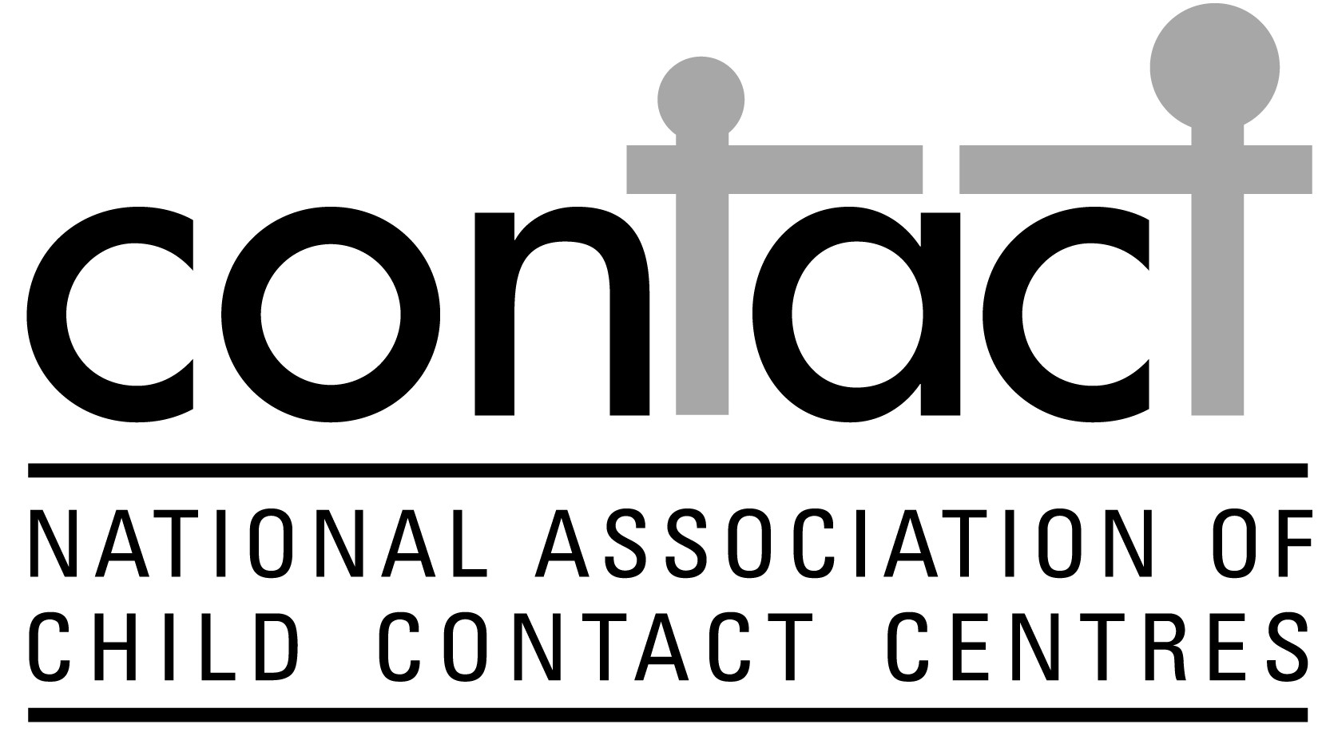

Resident Parent - All information will be kept confidential
This form should be completed in full before any contact is allowed to commence. Please answer as fully as possible.

Contact Details
Name:
Address:

Telephone Number:
Mobile:
Email:
Children’s Names | DOB: |  | Age: |  |  | Gender

Relationship
When did your relationship with the children’s father/mother end?
Why did your relationship with the children’s father/mother end?

Has your family ever been known to or been involved with any of the following
CAFCASS |  | Yes |  | No
If yes please give dates, name of worker and details of involvement
Social Services |  | Yes |  | No
If yes please give dates and details, name of worker and details of involvement
The Courts |  | Yes |  | No
If yes please give dates and details of outcome and any other upcoming Court Dates
Mediation services |  | Yes |  | No
If yes please give dates, name of worker and any further appointments
Do you have any concerns relating to domestic violence? |  | Yes |  | No
If yes please complete the attached form and give details
Do you have any concerns relating to drugs and/or alcohol? Yes No

If yes please complete attached form and give details
Do you have any concerns relating to Mental Health Issues |  | Yes No
Please give details including dates if applicable.
Do you or the non-resident parent have any convictions?
 |  | Yes |  | No
If yes please give details

Previous Contact

When and where did contact last take place?
Who was involved in the contact?
Why did the contact breakdown?

If they are old enough to understand and have a view, how do the children feel about having any contact?

Arrangements for Contact

When would you like contact at the centre to take place and for how long? Maximum of 2 hours
Will anybody else be involved in the contact?
Who will be bringing the children to the centre?
Who will be collecting the children from the centre?
Is there anybody else that will be allowed to take part in contact (grandparents or aunts and uncles)?
Is there any risk of abduction?
 |  | Yes |  | No
Are you prepared to meet the children’s father/mother?
 |  | Yes |  | No
Will staggered arrival and departure times be required?
 |  | Yes |  | No
Are you agreeable to us taking photographs if requested and issuing both parents with a copy?
 |  | Yes |  | No
Who has parental responsibility?
Are you agreeable to the children being taken out of the centre?
 |  | Yes |  | No
Do any of the children have any illnesses or allergies?
What language is spoken at home?
Will an interpreter be needed?
 |  | Yes |  | No
Are there any other issues you feel the centre needs to be aware of?

Agreement
- I confirm that the information contained within this form is to the best of my knowledge both accurate and true.
- I agree to abide by the rules of the centre if I am offered a place
- I understand that the centre reserves the right to either refuse or terminate contact if I have withheld any information or behave in a way that breaks the centres rules.

Signed |  | Resident Parent
Print name |  | Resident Parent
Signed |  | The Contact Zone Child Contact Centre
Print name |  | The Contact Zone Child Contact Centre
Date

Domestic Violence Concerns

Please explain the details of what has happened?

When did this occur?

Throughout the relationship? Yes No
After the break up? Yes No
After Contact was refused Yes No

Were the Police involved? Yes No

If Yes what was the outcome?

Was there a conviction? Yes No

If Yes please give details:

Was any violence displayed towards the child/ren? Yes No

If yes please give details:

Did the children witness any of the violence stated? Yes No

If yes please give details and state how you feel this may affect contact:

Please give any further information that you may be relevant to this section:

I declare that the information given on this form is accurate and understand that any false information will result in the application being refused.

Signed:
Name:
Date:

Please note that any information given on this form will be fully investigated and will not necessarily mean that contact will be refused. If The Contact Zone feels that they are unable to support contact because of the information received, contact may be referred to a Supervised Contact Centre instead. If this is the case, both parties will be informed and help can be given to find a suitable centre.

Drug/Alcohol Concerns

Does your concern involve Drugs Alcohol Both

If it concerns drugs please list the drugs involved

Please give details of what has happened with drugs/alcohol

Have you or your ex partner sought or received help? Yes No

Please give details including any agencies currently involved:

Have the incidents mentioned ever involved the Police? Yes No

What was the outcome?

Were there any convictions received? Yes No

If yes please give details

Have any of the incidents you have mentioned previously happened in front of the child/ren?
Yes No

If yes please give details:

If yes how has this, in your opinion, affected your son/daughter?

Please give any further information that you may be relevant to this section:

I declare that the information given on this form is accurate and understand that any false information will result in the application being refused.

Signed:
Name:
Date:

Please note that any information given on this form will be fully investigated and will not necessarily mean that contact will be refused. If The Contact Zone feels that they are unable to support contact because of the information received, contact may be referred to a Supervised Contact Centre instead. If this is the case, both parties will be informed and help can be given to find a suitable centre.

